# **How to** useGoogle Colab

**Google Colab (short for Colaboratory)** is a free, cloud-based platform developed by Google that allows users to write and execute Python code in a web-based environment.

**Getting Started with Google Colab**

1. Visit <https://colab.research.google.com/>
2. Create a new notebook
3. Insert a **markdown****cell** and type some title text. Format as necessary
4. Insert a **code cell** and type some code e.g. the **print** statement “ Welcome to EASY-ML”

**Press shift + Enter** to run the code

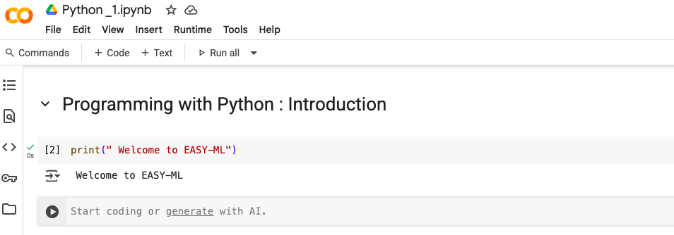

**Runtime**

The runtime tab provides a variety of options to run your code.

